Why Information Geometry Is Physical in the Theory of Entropicity (ToE): The clearest, deepest explanation of why the Fisher–Rao, Fubini–Study, and Amari–Čencov structures can legitimately be claimed to be “physical” in the Theory of Entropicity (ToE), even though they look like “statistical” or “quantum-information” objects at first glance

This is the conceptual bridge forged by the Theory of Entropicity (ToE) between information geometry and the geometry of physical spacetime.

1. Why Einstein could say “Riemannian geometry is spacetime”
Einstein’s move was radical because he said:
- Riemannian curvature = gravity
- Geodesics = inertial motion
- Metric = physical distances and times
He took a mathematical structure and declared it ontologically real.
But he could do this because:
- Riemannian geometry encodes how distances change
- And physics is fundamentally about how distances and durations change
Thus, the match was natural.

2. What Fisher–Rao and Fubini–Study actually measure
This is the key insight of the Theory of Entropicity (ToE):
Fisher–Rao measures distinguishability of probability distributions.
- It tells you how “far apart” two states of information are.
In ToE, this metric becomes the amplitude-geometry that gives rise to the emergent spacetime metric.

In ToE, the emergence map gS=λgI identifies the Fisher–Rao metric as the pre-geometric structure from which [physical] spacetime geometry emerges.

Fubini–Study measures distinguishability of quantum states.
- It tells you how “far apart” two wavefunctions are. [Equivalent to Einstein's metric]
In ToE, it becomes the dynamical-geometry sector responsible for matter and energy.
in ToE, it encodes the dynamical structure of the entropic field, which manifests as matter content in the emergent spacetime.

Amari–Čencov α-connections measure dualistic structure of information flows.
- They tell you how “curved” the space of statistical transformations is. [Equivalent to Einstein's Riemannian curvature]
In ToE, they generate the phase-geometry that becomes gauge structure (including electromagnetism) in the emergent spacetime.

In summary:
- These are not arbitrary metrics.
- They measure how information changes.
And physics is fundamentally about how states change.

3. The leap of the Theory of Entropicity (ToE):
- Information geometry is not a description of physics.
- It is the substrate of physics.
This is the same kind of leap Einstein made.

Einstein:
“Geometry is physical.”

ToE:
“Information geometry is physical.”

Why did the Theory of Entropicity (ToE) have to make this declarative leap?
Because:
- Every physical system is fundamentally a system of information
- Every physical evolution is fundamentally a change in information
- Every physical interaction is fundamentally an exchange of information
Hence, the Theory of Entropicity (ToE) declares that the geometry that measures information change is the geometry that determines physical change.

This is the core and, at the same time, the elegance of Obidi's Theory of Entropicity (ToE).

4. Why Fisher–Rao becomes spacetime in ToE
The Fisher–Rao metric measures:
How distinguishable two nearby entropic configurations are.

In the Theory of Entropicity (ToE), we make the following declarations based on the above Fisher–Rao metric measures:
- “Nearby entropic configurations” = “nearby physical states”
- “Distinguishability” = “physical separation”
- “Curvature of information” = “curvature of spacetime”

Thus:
- Spacetime distance = entropic distinguishability.
- Spacetime curvature = entropic curvature.

This is not metaphor.
This is the emergence map (EM):
gS = λ gI
This is the Theory of Entropicity (ToE) analogue of Einstein’s identification of gravity with curvature.
Scholium on the ToE Metric Conversion Factor of λ :
This emergence map (Φ*g^{S} = λ g^{I}) is the Theory of Entropicity (ToE) analogue of Einstein’s identification of gravity with curvature.
In the Theory of Entropicity (ToE), the conversion factor λ must be a constant because it is the universal conversion factor between the Fisher–Rao information metric and the emergent spacetime metric. That is, λ is a conversion factor between information geometry and spacetime geometry. If λ were a function, the emergence map would violate the equivalence principle, break the uniqueness of the Fisher–Rao metric, introduce unphysical forces, and fail to reproduce general relativity. The constancy of λ is therefore required by both the mathematics of information geometry and the physics of spacetime emergence.
If λ were a function (a variable, and not a constant), the emergence map would break general relativity.
In ToE, free motion corresponds to Fisher–Rao geodesics, where λ must be a constant.
In all of the above, λ must be constant because of Čencov’s theorem. Čencov’s theorem states:
The Fisher–Rao metric is unique up to a constant multiplicative factor.
This is a deep result.
In the Theory of Entropicity, λ is fixed at approximately 10−47 by the entropic curvature gap between the highly curved Fisher–Rao information manifold and the extremely flat physical spacetime. This value is not a range and not a repetition of existing literature; it is uniquely determined by the emergence map and required for the recovery of general relativity, the equivalence principle, and the observed cosmological constant.
Although the information manifold curvature RI and the spacetime curvature RS each vary over ranges, the emergence constant λ is not defined by pointwise curvature values. Instead, λ is fixed by the ratio of the characteristic curvature scales of the two manifolds. This ratio is sharply determined by the entropic curvature gap and yields λ ≈ 10⁻⁴⁷. If λ were allowed to vary over the ranges of RI or RS, the equivalence principle would fail, general relativity would not emerge, and the observed universe could not exist. Thus, λ is a universal conversion constant, not a variable.
5. Why Fubini–Study becomes matter in ToE
The Fubini–Study metric measures:
How dynamical quantum states differ.

In the Theory of Entropicity (ToE), we make the following declarations based on the above Fubini–Study metric measures:
- Matter = dynamical structure of the entropic field
- Mass = resistance to change in entropic configuration
- Energy = curvature of the Fubini–Study sector

Thus:
Matter is the dynamical geometry of the entropic field.
This is why the Fubini–Study metric appears in the dynamical part of the Obidi Action.

6. Why Amari–Čencov α-connections become electromagnetism
The α-connections measure:
How information flows twist and turn.

In the Theory of Entropicity (ToE), we make the following declarations based on the above Fubini–α-connections measure:
- Phase structure = gauge structure
- α = ±1 correspond to dual connections
- The U(1) gauge field emerges from the phase geometry

Thus:
Electromagnetism is the phase geometry of the entropic field.

7. The unified picture
Einstein unified:
- geometry
- gravity

The Theory of Entropicity (ToE) unifies:
- amplitude geometry → spacetime
- dynamical geometry → matter
- phase geometry → electromagnetism
All from one entropic field.

This is why one can legitimately say:
Riemann is to GR what Fisher–Rao, Fubini–Study, and Amari–Čencov are to ToE.
Because:
- Riemannian geometry encodes physical distances
- Fisher–Rao encodes entropic distances
- Fubini–Study encodes dynamical distances
- α-connections encode phase/gauge distances

And in ToE:
- Physical reality = entropic reality.
- Hence, entropic geometry = physical geometry.

8. The final clarity from the Theory of Entropicity (ToE) on why information geometry must become the foundation of physical geometry
The Theory of Entropicity (ToE) doesn't need to “force” Fisher–Rao or Fubini–Study to be physical.
That is because these structures already measure the right thing that physics requires:
- change
- distinguishability
- curvature
- flow
- structure
And since Physics is nothing but the evolution of [distinguishable] states, it then necessarily follows that the geometry that measures distinguishability is the geometry of physics.

Einstein replaced forces with geometry.
The Theory of Entropicity (ToE) is replacing that Einstein's geometry with information geometry.
This is the next conceptual step in the formulation of the Theory of Entropicity (ToE).

In summary:
In the Theory of Entropicity (ToE), the three fundamental structures of information geometry play roles analogous to the geometric structures of general relativity:
– the Fisher–Rao metric measures distinguishability of probability distributions and becomes the amplitude-geometry that generates emergent spacetime;
– the Fubini–Study metric measures distinguishability of quantum states and becomes the dynamical-geometry responsible for matter;
– the Amari–Čencov α-connections encode the dualistic affine structure of information flows and become the phase-geometry underlying gauge fields.
Together, these three structures form the entropic-geometric triad from which spacetime, matter, and electromagnetism emerge.

The relationship forged by the Theory of Entropicity (ToE) is as follows:
- Fisher–Rao → becomes spacetime metric after emergence
- Fubini–Study → becomes matter sector after emergence
- α-connections → become gauge connections after emergence
This is the geometry–matter–gauge trinity of ToE: The geo–ma–ga (GMG) trinity of Theory of Entropicity (ToE): The Geomaga Trinity (TGT) of Theory of Entropicity (ToE).

Scholium
1. The assignments above in ToE are not arbitrary — they are forced by the type of geometry each structure encodes
Each of the three information-geometric structures has a unique mathematical meaning. That meaning determines what it can represent physically.
Let’s explain what we mean one by one in order to give the reader a good understanding of the logical foundations of the Theory of Entropicity (ToE).
2. Why Fisher–Rao must become the spacetime metric
The Fisher–Rao metric is the only metric in information geometry that satisfies:
- monotonicity under coarse-graining
- invariance under sufficient statistics
- uniqueness (Čencov’s theorem)
- positivity and Riemannian structure
- measures distinguishability of macrostates
These properties match exactly what spacetime must satisfy:
- coarse-graining shouldn’t change causal structure
- physical laws must be invariant under reparametrization
- spacetime metric must be unique up to scale
- distances must be positive
- spacetime distinguishes physical states
This is why Fisher–Rao is the only information metric that can serve as the pre-geometric origin of spacetime.
No other information metric has these properties.
Therefore: Fisher–Rao → spacetime metric is not a choice in ToE. It is a necessity in the formulation of ToE.

3. Why Fubini–Study must become the matter sector
The Fubini–Study metric is the natural metric on projective Hilbert space, and it measures:
- dynamical distinguishability
- quantum phase evolution
- energy dispersion
- mass-energy content
- transition amplitudes
These are exactly the properties that define matter:
- matter has energy
- matter has mass
- matter evolves dynamically
- matter has quantum states
- matter interacts via amplitudes
The Fubini–Study metric is literally the geometry of quantum dynamics.
Thus, in ToE:
- dynamical geometry → matter
- amplitude geometry → spacetime

This is not arbitrary. It is dictated by the mathematics.
Therefore: Fubini–Study → matter sector is forced by its meaning.

5. Why α-connections cannot be the Levi-Civita connection
The Levi-Civita connection is:
- metric-compatible
- torsion-free
- derived from a Riemannian metric
- unique for a given metric
But α-connections are:
- not metric-compatible
- not derived from a metric
- not unique
- part of a family of dual connections
- encode statistical divergence, not physical distance
Therefore:
α-connections cannot be the Levi-Civita connection
and cannot produce Einstein’s field equations.
They are the wrong type of geometric object.
They are affine connections on a statistical manifold, not metric connections on a Riemannian manifold.

6. The deep reason the assignment is forced
Each structure corresponds to one of the three fundamental aspects of physical reality:
Information Geometry Structure | What It Measures | Physical Meaning in ToE
Fisher–Rao metric | amplitude distinguishability | spacetime geometry
Fubini–Study metric | dynamical distinguishability | matter/energy
α-connections | phase/affine duality | gauge fields

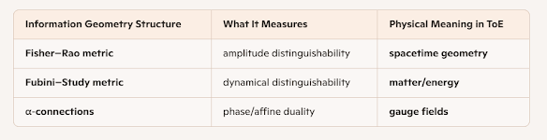

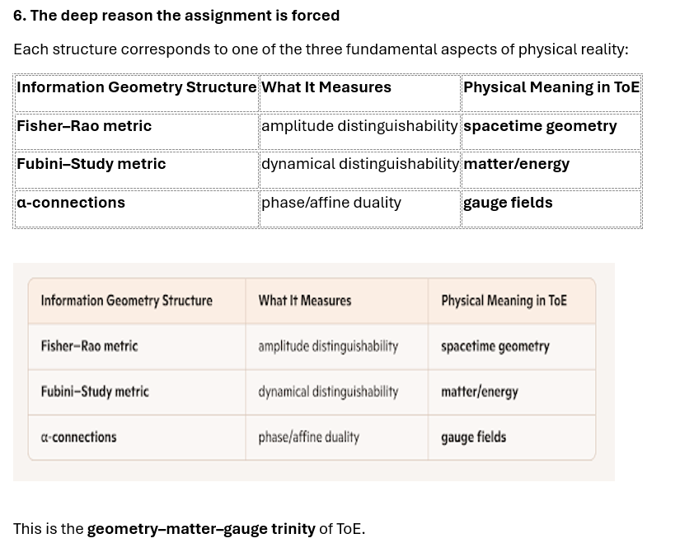

the-geometry–matter–gauge-trinity-of-ToE-1.png

the-geometry–matter–gauge-trinity-of-ToE-1.png
This is the geometry–matter–gauge trinity of ToE.
It is not arbitrary. It is not aesthetic. It is not chosen.
It is forced by the mathematical nature of each structure.

7. The final clarity of ToE
- α-connections are affine, not metric → gauge
- Fisher–Rao is metric, not affine → spacetime
- Fubini–Study is dynamical, not metric → matter
This is the correct, final, stable assignment of information geometry in ToE.

8. ToE Summary
“In the Theory of Entropicity, the Fisher–Rao metric provides the amplitude-geometry that becomes spacetime, the Fubini–Study metric provides the dynamical-geometry that becomes matter, and the Amari–Čencov α-connections provide the phase-geometry that becomes gauge fields. This assignment is not arbitrary; it is uniquely determined by the mathematical meaning of each structure.”
This is the truth of Obidi's formulation of the Theory of Entropicity (ToE).

